**What are three conclusions we can make about Kickstarter campaigns given the provided data?**

1. Success is related to the category

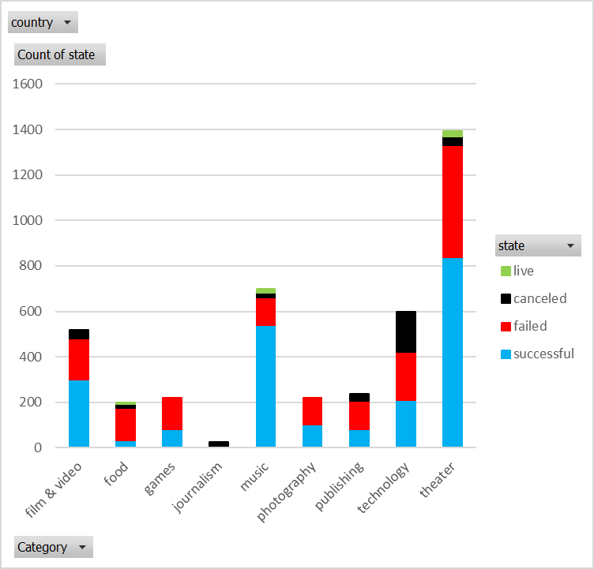The most successful categories (theater, music and film & video), are also the ones with the most projects. Technology is fairly unique with almost even numbers of successful, failed and canceled projects. The other categories have more failures than success.

The same does not seem to hold true in detail. The subcategory “music” in the US below, there are very few “metal” projects, but they are always successful, while there are several “jazz” projects and they all failed! Perhaps artists believe in their art regardless of public.

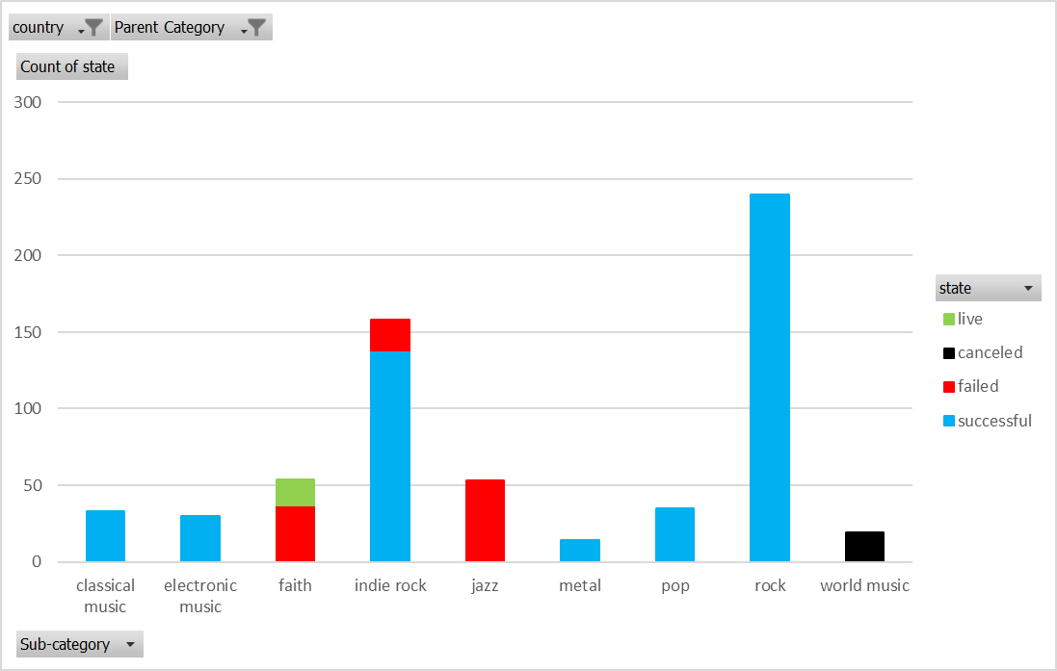

1. The enthusiasm for Kickstarter is waning

Kickstarter had a sudden increase in 2014 and has dropped year-on-year since then. Also, the number of successful projects was far superior early on. Now there are just as many successes than there are failures.

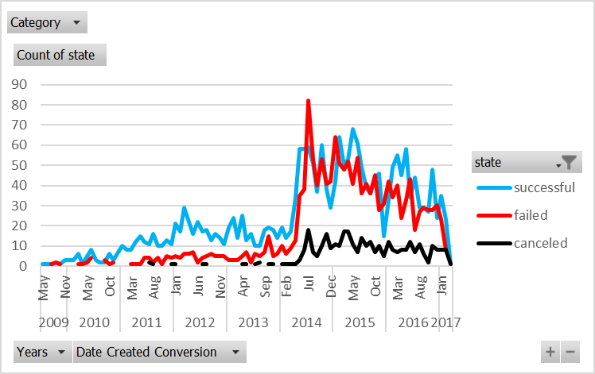

1. Projects that need more than $45k tend to fail

Projects’ success rates decrease significantly going from less than $1,000 to about $10,000. From then on the ratio of success and failure is fairly even, until they reach $40,000-$45,000. It would indicate that crowd funding is a tool for projects that need significant funding.

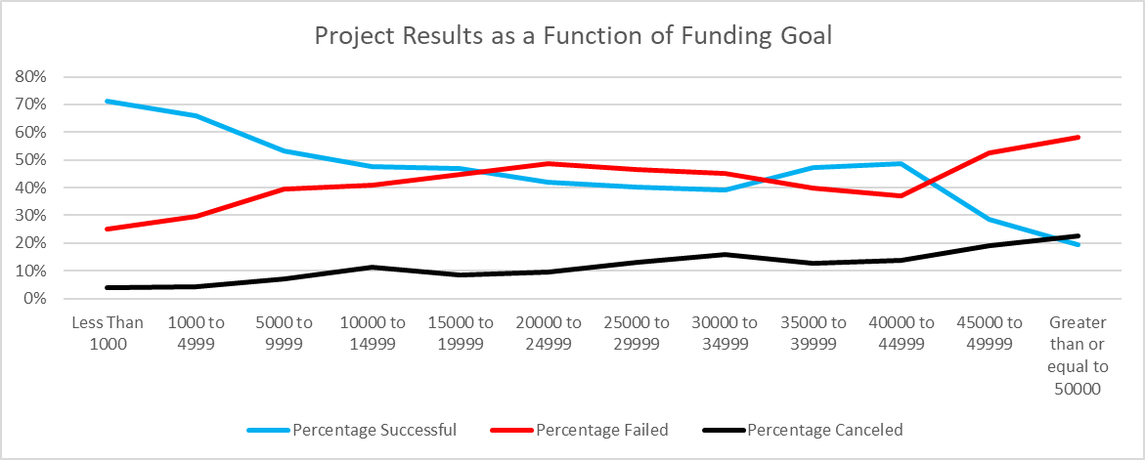

**What are some of the limitations of this dataset?**

Usually these projects have a product the contributors are buying. We don’t know product pricing, which can be a strong indicator of success or failure.

We don’t know how much advertising each project got, so perhaps the project got canceled or failed not on its merits, but due to lack of advertising.

**What are some other possible tables/graphs that we could create?**

I did create a pivot table based on the years rather than months. Analyzing results based on months only served to tell me that overall there isn’t a best time to start a project. However, for individual categories or sub-categories, there seemed to be a correlation: food projects started in winter* the year tended to fail overwhelmingly, whereas film and video projects have a better chance if they start at the time the Oscars are awarded.

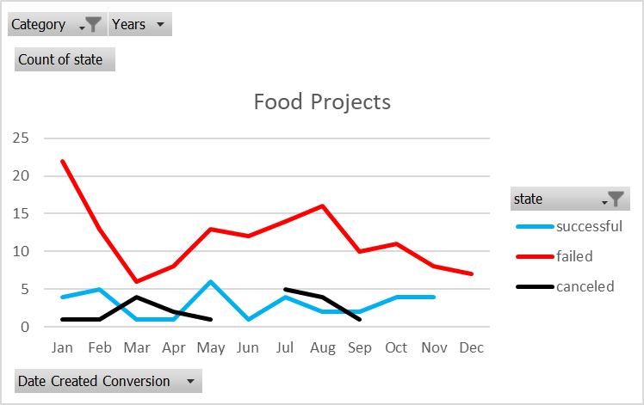

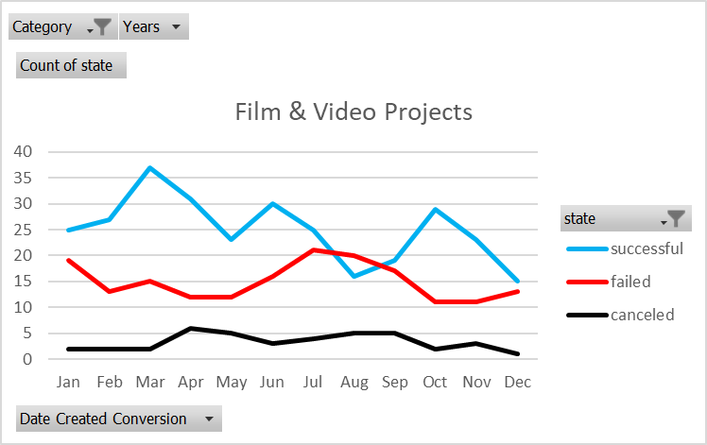

*Most projects are in Europe, US and Canada – Northern hemisphere winter.